Aniket Pant

PHIL 3127 (3A). Fall 2020.

Abstract

In 1988, E. Herman and N. Chomsky published Manufacturing Consent, a seminal text exposing insights in the manufacture of public information and its dependence on the interests of the private elite. Herman and Chomsky used analytical methods to describe the disparate media coverage similar events received in the news via their paired case study methodology. In my work, I apply the paired case study methodology to study the attempted murder of Sergei Skripal and the murder of many Iranian nuclear scientists. Using advanced natural language processing techniques, I find that the media coverage of these two similar events is not equal and is presented in different ways. My findings support Herman and Chomsky’s thesis, in that the analyzed media reflects the interests of those elites interested in its portrayal.

NYT: Applied manufacturing consent

Paper 2: Sergei Skripal and Nuclear Scientists

# Propaganda Model: Overview

In 1988, Edward S. Herman and Noam Chomsky published *Manufacturing Consent*, an analytical novel focused on exposing the influence of the media’s financers in the publication of American media. Herman, at the time of writing, was a professor of finance at Wharton School at the University of Pennsylvania. Chomsky, now often referred to as the “father of modern linguistics”, was an active linguist and scholar. In *Manufacturing Consent*, Herman and Chomsky employ a “paired case study” methodology to compare the media coverage of two similar events. Using this paired case study method, Herman and Chomsky evaluate the role of various techniques to bias and influence perception of American media through its presentation. The central thesis of Herman and Chomsky’s *Manufacturing Consent* claims that “The media serve, and propagandize on behalf of, the powerful societal interests that control and finance them” (LND, PAGE). In *Manufacturing Consent*, through their use of the paired case study, Herman and Chomsky find that similar events are offered differing media coverage based on elite interest.

The Cartographer’s Paradox states that any map of the world must be distorted – a 1:1 scale map is an absurd suggestion. For any map to be useful, it must be imperfect. Similarly, no piece of media can perfectly represent reality – it must contain some inherent bias, misrepresentation, and is generally limited in its capabilities as a representation of reality. In *Manufacturing Consent*, Herman and Chomsky investigate the mechanisms for facilitating the spread of propaganda and misrepresentation in American media. Using the paired case study method previously mentioned, Herman and Chomsky suggest that the media decides “worthy” and “unworthy” victims, those worthy and not worthy of media attention and coverage. Additionally, Herman and Chomsky suggest that the spread of propaganda is facilitated by the use of five main techniques: omitting inconvenient facts, emphasizing news with a negative sentiment, telling few and infrequent lies, strategic placement, and appealing to emotions. Herman and Chomsky

Section 2

1. Cartographer’s Paradox – if a news article were a perfect representation of the described reality, it would no longer be a newspaper.
2. Bias is an inherent fault of any media publication.
3. How is propaganda propagated in the media?
4. Discuss the techniques enlisted by Herman and Chomsky
   1. Paired case study method
      1. El Salvador vs. XYZ
5. Filters and Lenses

Section 3

1. Why does it matter for the average person?
2. More organic discussion
3. Matters because it decides the reality, we can perceive
4. Shapes every aspect of our daily life
5. We live under the “statutes and formulas” provided to us by the media. Kant would say ridding ourselves of this self-incurred tutelage is a first step on the way to enlightenment.

# Comparison

## Word Counts

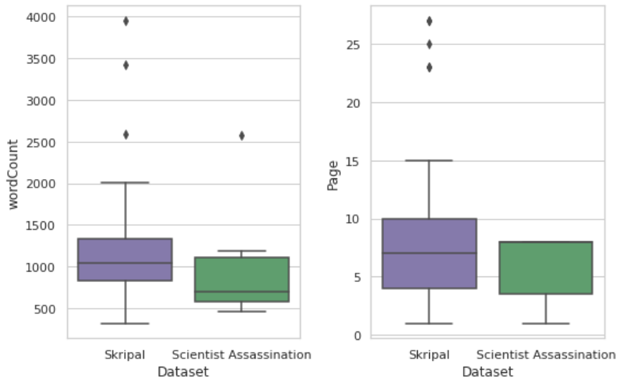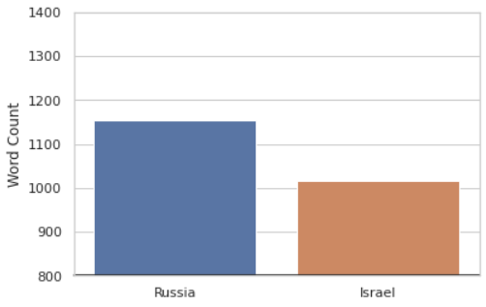

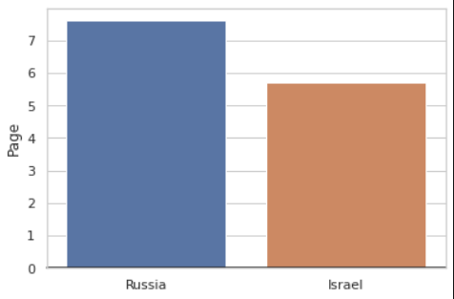

Key findings

1. Articles about Skripal were often published on later pages
   1. Mean
      1. With a mean of page 5.714285714285714 for articles about scientist assasinations
      2. With a mean of page 7.611650485436893 for articles about Skripal
   2. Median
      1. 8.0 median for articles about scientist assassinations
      2. 7.0 median for articles about Skripal
2. Articles about Skripal often possessed more words than articles about scientist assassinations.
   1. Mean
      1. 1015.8571428571429 for articles about scientist assassinations
      2. 1153.4077669902913 for articles about Skripal
   2. Median
      1. 693.0 for articles about scientist assassinations
      2. 1040.0 for articles about Skripal
3. Why:
   1. This may be due to a multitude of reasons. One explanation may be attributed to differences in conveyed sentiment. Perhaps articles about Skripal possess more negative sentiment, pertinent to anti-Russia propaganda, and thus use more words to convey this. This will be further discussed in the sentiment section.
   2. Insights on why articles about Sergei Skripal were often found on later pages in published volumes requires further insights on the contents of the rest of the publication. Perhaps this can be attributed to repressing the publication of news about Russia. By placing this news on latter pages, less eyes may read it.

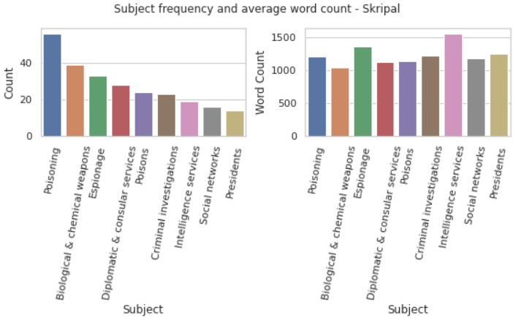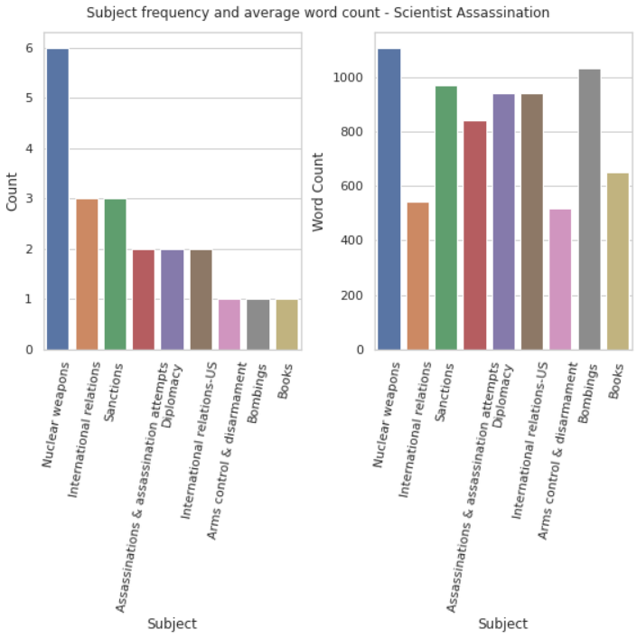

Key findings:

1. Articles about Skripal are often about more emotional, provocative subjects like “poisoning”, “biological weapons”, and “espionage”.
   1. On average, word count for all subjects is mostly equal. Word count is spread more evenly, on average.
2. In contrast to this, articles about scientist assassinations are often about objective subjects like “nuclear weapons”, “international relations”, and “sanctions”.
3. It is difficult to make definitive conclusions about these samples due to limits in sample populations.

## Keywords

## Sentiment Analysis

### Methodology

Powerful insights can be extracted from understanding the sentiment behind written text. When Herman and Chomsky published Manufacturing Consent in 1988, this would be next to impossible without a subjective process and heuristic processes – with recent advancements in natural language processing, analyzing the sentiment of hundreds of articles can be easily performed.

In this work, I apply the Valence Aware Dictionary and sEntiment Reasoner (VADER) sentiment analysis algorithm to calculate sentiment polarities present in each prescribed article.

## Topics

Take Word2Vec/Doc2Vec(?) embeddings. Do HDBSCAN. How many clusters does this give? What are the contents of the cluster?

# Conclusion